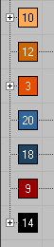
1 | yellow | Gunold 1065
2 | Light Brown | H 514
3 | Orange | China _ Orange
4 | Grey- Blue | Royal C443
5 | TURQUOISE | Gunold 1094
6 | Dark Orange | Royal C 723
7 | Black

